Current Operable Unit 3 Remedial Progress for Week Ending 12/11/09
Creamer Environmental Inc., National Grid’s Remediation Contractor, has started the excavation and backfill tasks where the LIRR tracks were relocated. To date 47 trucks have transported approximately 1287.65 tons of soil to Bay Shore Soil Management (formerly ESMI of NJ) for thermal desorption.
GEI, National Grid’s Remediation Oversight Consultant, continues to perform CAMP (Community Air Monitoring Program), Noise and Vibration monitoring. CAMP, Noise and Vibration monitoring will continue throughout the project.

Two-Week Outlook
Phase 1 sheet pile installation and construction will continue throughout the next several weeks. Full scale excavation and load out of impacted soil is anticipated to continue until late January or early February.
General hours of operation will continue to be Monday through Friday, 7:00 AM to 3:30 PM. However, work hours will be extended when necessary to maintain schedule or to complete critical tasks. Holiday work schedule will proceed until December 24th working a partial day to prepare the site for the holiday break. Work will restart Monday the December the 28th. A typical operations shift is anticipated on December 31st and work will restart Monday January 4th 2010.

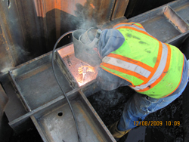
Welding structural supports to Waler system
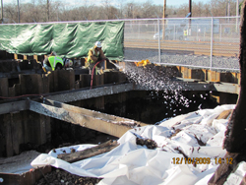
Applying odor controlling foam to excavtion

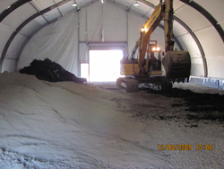
Soil stabilization material inside TFS

